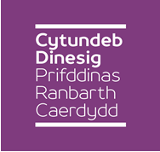
Cardiff Capital Region City Deal
Special Regional Joint Cabinet

Tuesday 02nd May 2017, 09.30 a.m.
Ty Dysgu, Nantgarw

Agenda

1. | Welcome and Apologies
2. | Declarations of Interest  To be made at the start of the Agenda Item in question, in accordance with the members Code of Conduct.
3. | Grant Funding Terms and Conditions Report  To receive the Report of the City of Cardiff Council Corporate Director of Resources in relation to the acceptance of the terms and conditions of the grant transfer from Welsh Government and HM Treasury to the Accountable Body.
4. | Annual Business Plan 2017-2018  To receive the Report of the Cardiff Capital Region Programme Director in relation to the proposed Annual Business Plan for 2017-2018.
5. | Compound Semi-Conductor Project Proposal  To receive the Report of the Cardiff Capital Region Programme Director in relation to a Candidate Scheme proposal seeking Wider Investment Fund support.

Sheila Davies
CCR Programme Director
25th April 2017

