Date | Author
December 2011 | Sarah Bowen, Inclusion
Revised April 2014 | Sarah Bowen, Inclusion Manager
Revised January 2017 | Sarah Bowen, Inclusion Manager
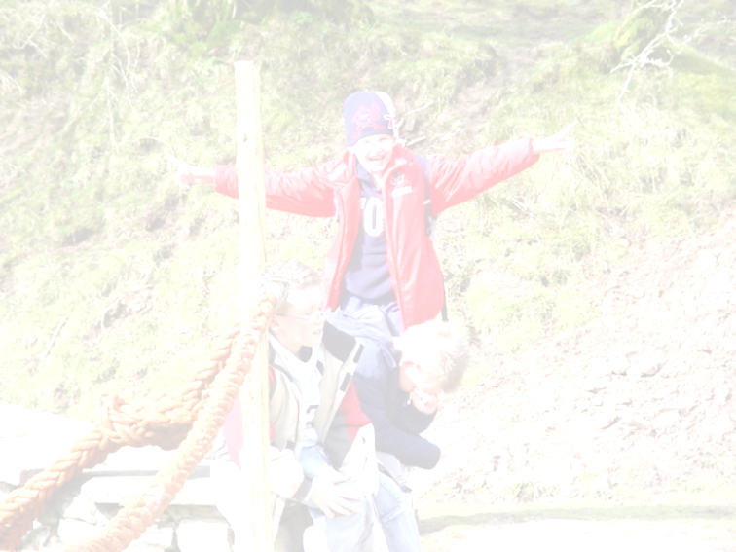

Gosod plant yn Gyntaf………..yn helpu i wella ysgolion
‘Putting children first ….. Helping schools improve’

CYNGOR BWRDEISTREF SIROL MERTHYR TUDFIL
Merthyr Tydfil County Borough Council

COMMUNITY SERVICES
2017-2020

Positive Behaviour Management Guidance

Including the use of physical intervention by staff

Contents | Page Number
Background | 3
Positive behaviour support | 5
Sanctions | 7
Physical intervention | 8
Reducing the likelihood of situations arising where the use of physical intervention may be required | 10
Deciding whether to use physical intervention | 12
Pupils with special educational need and or disabilities | 13
Staff training | 14
Recording and Reporting Incidents | 15
Risk assessment and planning for use of restrictive physical intervention | 16
Post-incident support | 17
Complaints and allegations | 18
Monitoring and review | 19
Framework for a School Policy on the use of physical intervention by staff | 19
Appendix A Examples of when physical intervention could be used | 22
Appendix B Primary Prevention | 24
Appendix C Guidance for staff on the use of physical intervention | 26
Appendix D Example of an Individual Behaviour Plan | 30
Appendix E Positive Behaviour Support Planning Tool | 33
Positive Behaviour Management Guidance
Including the use of physical intervention by staff

Summary

The guidance
- references the legal background, the rationale for positive behaviour management and specific guidance on the use of physical intervention.
- makes clear the exceptional circumstances in which physical restraint is to be used and the way in which it can be used.
- sets out recording and reporting forms and procedures
- highlights what to do following an incident
- focuses on both excellent education and quality of life
- keeps the young person at the centre of the planning.

This guidance has been developed upon the beliefs that behaviours that challenge can be reduced and often prevented by careful management of the environment and the consideration and understating of each child’s personal setting conditions.

Background

This document contains guidance on the powers available to schools to help manage pupils’ behaviour and pays regard to the powers that are contained in the following legislation and guidance:

- The “Use of Force to Control or Restrain Pupils”, the powers of which are contained in Section 93 of the Education and Inspections Act 2006, which replaced Section 550A of the Education Act 1996, with minor changes.
- The most recent information is outlined in the guidance document No: 097/2013 Safe and Effective Intervention-use of reasonable force and searching for weapons from the welsh government.

The majority of pupils behave well and schools are generally orderly and productive places of learning. This booklet provides support to enable all school staff to deal effectively with behaviour that challenges, whilst at the same time minimising the disruption to other pupils’ learning,.

This guidance intends to ensure clarity on what schools can do to promote positive behaviour and to promote greater consistency of application across the authority. This in turn will protect the rights of children and young people to be treated consistently and fairly.

The Welsh Government has put in place the School Effectiveness Framework in order to develop and promote effective approaches in schools in Wales, which includes the promotion of positive behaviour when dealing behaviour that disrupts. The Framework sets out a national purpose for schools and two elements of this are particularly relevant in terms of the purpose of maintaining schools as safe and protective environments which promote positive behaviour. These two elements are as follows:
- to enable all children and young people to develop their full potential by
acquiring skills, knowledge, understanding and attitudes, including
personal, social and emotional skills, to enable them to become economically, socially and personally active citizens and lifelong learners; and
- promote a culture of social inclusion and respect for diversity, particularly
through developing the wellbeing of learners and personalising their learning.

The School Councils Regulations 2005 require all maintained schools in Wales to have a school council that is democratically elected by pupils and which meets at least six times a year. The school council is a democratic channel which allows all pupils to have a voice and to be listened to, as set out in Article 12 of the United Nations Convention on the Rights of the Child (UNCRC). The Welsh Government recommends that schools develop a whole-school Participation Policy setting out a variety of ways in which pupils can be actively involved in decisions that affect them at different levels of schools life (e.g. including class councils, eco-schools, healthy schools, peer mentors, assessment for learning, etc). The LA endorses this with annual Student Council Conferences for both primary and secondary aged pupils. In addition to this, the LA has brokered support for schools to access and adopt the Rights Respecting Schools Award (RRSA).

Positive behaviour is a matter of concern for all pupils, ensuring that they experience a safe and positive learning environment. Relevant policies are more likely to be respected and adhered to where pupils are directly involved in formulating and monitoring behaviour policies and have a stake in them.

In involving pupils in promoting and implementing positive behaviours, schools should adhere to the National Children and Young People’s Participation Standards for Wales.

This guidance should be seen within the framework of inclusion and pupil support set out in Welsh Assembly Government Circular 47/06 and the “Safe and Effective Intervention-Use of Reasonable Force” and “Searching for Weapons” Guidance document No: 097/2013. It should also be considered alongside the overall suite of guidance on these aspects including those for exclusions, tackling bullying and the SEN Code of Practice.

Any use of positive behaviour management, with regards to physical intervention must be reasonable, proportionate and comply with:
• Local Authority policies.
• United Nations Convention on the Rights of the Child (UNCRC)
• School discipline and behaviour policies.
Welsh Government guidance (as mentioned above)

Positive Behaviour Support (PBS)

All staff should adopt a positive approach to improving behaviour in line with the school Behaviour Policy. This approach will help to ensure that early and preventative intervention is the norm. It should reduce the incidence of extreme behaviours and make sure that the use of physical intervention is rare.

As an authority Merthyr Tydfil promotes the Prospect Training on Safe and Effective Handling as set out by Jon Hull and the strategies outlined in the Behaviour Handbook, On Task and Learning Toolkit and its Supplement. The intention of the latter is to provide teachers and support staff with an easily accessible manual of information, guidance, exemplar material and resources on a range of issues relevant to supporting the learning of those children and young people who experience behavioural difficulties.

The key themes of Positive Behaviour Support are:

- Authentic positive relationships and participation
- Person centred approaches
- Environmental manipulation
- Recognising that challenging behaviour does not occur in a vacuums i.e. it occurs witan the environment
- Early intervention and prevention
- Recognizing that needs vary from child to child
- The development of understanding behaviour
- Increased choice and empowerment for the pupils
- Increase in behavioural skills to address unmet needs
- Development of individual support plans
- Avoidance of punitive consequences

The content of the modules that would be covered in Positive Behaviour Support are:

- Behavioural Risk Assessment
- Scatter plots
- Star Charts
- PBS planning
- Developing Functionality equivalent skills
- Monitoring and further development
- Deflection techniques (reassuring and redirecting)

Effective positive behaviour support relies on a clear definition of what challenging behaviour is. The most commonly adopted definition of “challenging behaviour”, a term now commonly used within education services, health and social services is:

“...behaviour of such an intensity, frequency or duration that the physical safety of the person or others is likely to be placed in jeopardy, or behaviour which is likely to seriously limit or deny access to and use of ordinary community facilities”.
(Emerson, 1995 p.44)

All staff should adopt a positive approach to improving behaviour in order to reward effort and application, and to build self-esteem. The following note, while relevant to all schools is even more so when dealing with pupils with ALN, where communication difficulties can render challenging behaviour more common place. The school should work in partnership with those who know the child to help those concerned to:
- find out why this child behaves as he or she does;
- understand the factors that influence this child’s behaviour; and
- identify early warning signs that indicate foreseeable behaviours are
developing.

The term ‘challenging behaviour’ should be reserved for behaviours which are dangerous or significantly interfere with the pupils’ lifestyles. Challenging behaviour is more common where there are communication difficulties. It often serves one or more functions (i.e. escape, to gain tangibles, to gain attention or sensory feedback), helping the pupil to control some aspects of their environment more successfully.

Models for understanding challenging behaviour can be used to assess (i.e. functional analysis) and to plan effective and positive intervention programmes to reduce the frequency and duration of the problem behaviour. Interventions are more effective if they are based on the assessment of the functions of the behaviour, and instigate effective changes to the support given and within the immediate environment of the pupil.
There should be a commitment to early intervention, prevention and positive approaches to understanding challenging behaviour, and an investment in appropriate training and resources to support the often intensive work required.

This approach will help to ensure that early and preventative intervention is the norm and should reduce the incidences of extreme behaviour.

School staff should refer to the school’s behaviour policy when developing and implementing behaviour management plans. All behaviour management plans should be formally agreed and ratified before implementing them in school. Plans should be formally recorded in accordance with school procedures and set out the action taken to:
- meet the pupil’s needs;
- encourage the pupil to make positive choices and develop self-control;
- support the pupil in difficult situations; and
- safely manage crises if and when they occur.

Sanctions

The use of both sanctions and rewards should be outlined in a school’s behaviour policy and should be clear to staff, parents/carers and pupils. Should a form of “time out” be deemed as an appropriate sanction then this method should be part of a therapeutic programme to manage a challenging behaviour and not handed out in an ad hoc manner.

When a form of “time out” is used the individual with challenging behaviour should be taken away from a place or an activity that is considered rewarding to them when their behaviours become unmanageable. The person can merely be taken out of the room or a few paces away from where an activity is being held.

Time out is defined in paragraph 19.9 of the Mental Health Act 1983 Code of Practice as:

“A behaviour modification technique which denies a patient for a period of time (lasting for a few seconds to no more than fifteen minutes) opportunities to participate in an activity or to obtain positive reinforcers following (normally immediately) an incident of an unacceptable or unwanted behaviour, and which then returns the patient to his/her original environment. Time out should never include the use of a locked room. ”

Notwithstanding the ethical dilemma of using punishment as a consequence, if that punishment involves the use of force then it is unlawful. This is because it would fall within the definition of corporal punishment, abolished by section 548 of the Education Act 1996.
The practice of using punishment for a pupil who is essentially attempting to communicate a message or access legitimate reinforces e.g. to escape a situation or have interaction from staff, is ethically non-viable. Non aversive approaches should be applied to teach/develop more adaptive or appropriate means of communication to achieve the same reinforces. If the function of the behaviour is understood by staff (however severe the problem) it will be more effective for staff to implement strategies to help the pupil self- manage or change their own behaviour.
Because of the comprehension difficulties associated with individuals who have autism and communication difficulties punishment is generally not ethically viable. All pupils whose behaviour is having such an impact on their ability to engage with their school work should have a full functional analysis completed. This in turn will lead to an individual Positive Behaviour Support Plan outlining the interventions including positive programming, developing alternative communication systems, manipulating the environment to support the pupil and other non-aversive procedures in place.

Physical intervention

“Force should be used as a protective measure and never as a disciplinary penalty”. (Education Act 1996 Section 548)

All school staff members have a legal power to intervene to prevent pupils committing a criminal offence, injuring themselves or others, or damaging property; and to maintain good order and discipline amongst pupils.

The focus should be on preventing, as far as possible, the need for the use of physical intervention, by creating a calm, orderly and supportive school climate that lessens the risk and threat of violence of any kind. Physical intervention is only one aspect of the strategies available to staff when managing challenging behaviour and should only be used as the last resort. Staff should be encouraged to ensure that pupils who present with challenging behaviour are presented with opportunities to behave effectively through:
- Positive behaviour management programmes;
- Conflict resolution strategies; and
- Calming strategies

It is vey important that all preventative steps have been taken to negate the need to use physical intervention. However, this may not always be possible and in such circumstances staff need to be aware of sensitivities associated with any form of physical contact with pupils.

Schools should never seek to inhibit the ability of staff to use physical intervention by adopting a ‘no contact’ policy. The ability to use physical intervention helps ensure pupil and school safety and the risk with a no-contact policy is that it might place a member of staff in breach of their duty of care towards a pupil, or prevent them taking an action needed to prevent a pupil causing injury to others.

The Welsh Assembly Government guidance “Framework for Restrictive Physical Intervention Policy and Practice” defines Restrictive Physical Intervention as:
“Direct physical contact between persons where reasonable force is applied against resistance, either to restrict movement or mobility or to disengage from harmful behaviour displayed by an individual”
The guidance suggests organisations have a threefold focus as follows:
- Preventing the necessity for physically restrictive intervention through the development of preventative strategies;
- Working with the individual towards reducing the level of response needed where a potential need for restrictive physical intervention is identified as part of the individual planning and service delivery process;
- Where situations requiring restrictive physical intervention are identified as unavoidable, ensuring that there is prior planning and training to achieve safer outcomes for all concerned.
Where possible the use of Restrictive Physical Interventions will always be part of a multi element planned approach. It is accepted that there may be situations that could not be reasonably predicted or planned for and these situations rely on staff using their professional judgement and decision making alongside dynamic risk assessment skills to ensure that any intervention is the least restrictive and maintained for the shortest possible time to reach the desired outcome.
Restrictive Physical Interventions must never be used as punishment, but only ever as a way of keeping individuals safe.
The guidance “Safe and effective intervention – use of reasonable force and searching for weapons.” Suggests the following judgements that should be considered when making the decision to use Restrictive Physical Interventions they are as follows:
- The seriousness of the incident, assessed by the effect of the injury, damage or disorder which is likely to result if force is not used. The greater the potential for injury, damage or serious disorder, the more likely it is that using force may be justified;
- The chances of achieving the desired result by other means. The lower the probability of achieving the desired result by other means, the more likely it is that using force may be justified; and,
- The relative risks associated with physical intervention compared with using other strategies. The smaller the risks associated with physical intervention compared with other strategies, the more likely it is that using force may be justified.
Please see Appendix A for more details and examples of when physical intervention should and should not be used.

Staff authorised to use physical intervention

In the school policy the headteacher needs to ensure that it states which staff, if not all staff, are authorised to use physical intervention when dealing with incidents.

Physical interventions should only be considered after all other de-escalation methods have been tried first or if there is a real immediate risk to the pupil or others.

Some examples of situations where physical intervention might be used are:

- to prevent a pupil from attacking a member of staff, or another pupil, or to stop a fight between two or more pupils;
- to prevent a pupil causing serious, deliberate damage to property;
- to prevent a pupil causing injury or damage by accident, by rough play, or by misuse of dangerous materials or objects;
- to ensure that a pupil leaves a classroom where the pupil persistently refuses to follow an instruction to do so;
- to prevent a pupil behaving in a way that seriously disrupts a lesson; or
- to prevent a pupil behaving in a way that seriously disrupts a school sporting event or school visit.

A refusal of a pupil to remain in a particular place is not enough on its own to justify use of force. It would be justifiable when allowing a pupil to leave would:
- Entail serious risks to the pupil's safety (taking into account age and understanding), to the safety of other pupils or staff, or of damage to property; or lead to behaviour that prejudices good order and discipline, such as disrupting other classes;
- A pupil persistently refuses to follow an instruction to leave a classroom;
- A pupil is behaving in a way that seriously disrupts a lesson; or a pupil is behaving in a way that seriously disrupts a school sporting event or school visit.

In these examples the use of physical intervention would be reasonable, and therefore lawful, if it was clear that the behaviour was sufficiently dangerous or disruptive to warrant physical intervention of the degree applied and could not realistically be dealt with by any other means. The main aim of physical intervention is usually to maintain or restore safety. It is acknowledged that there may be times when restrictive physical intervention may be justified as a reasonable and proportional response to prevent damage to property or to maintain good order and discipline in schools.

Reducing the likelihood of situations arising where the use of physical intervention may be required

There are a number of steps that schools can take to help reduce the likelihood of situations arising where the use of physical intervention may be required:

- creating a calm, orderly and supportive school climate that minimises the risk and threat of violence of any kind;
- developing effective relationships between pupils and staff that are central to good order;
- adopting a whole-school approach to developing social and emotional skills such as the Social and Emotional Aspects of Learning (SEAL) programme;
- taking a structured approach to staff development that helps staff to develop the skills of positive behaviour management; managing conflict and also to support each other during and after an incident. Further guidance is provided in the Welsh Government’s Inclusion and Pupil Support Guidance, Circular 47/2006;
- effectively managing individual incidents. It is important to communicate calmly with the pupil, using non-threatening verbal and non-verbal language and ensuring the pupil can see a way out of a situation. Strategies might include, for example, going with the staff member to a quiet room, away from bystanders or other pupils, so that the staff member can listen to concerns; or being joined by a particular member of staff well known to the pupil; further strategies can be found in On Task and Learning; and
- wherever practicable, warning a pupil that force may have to be used before using it.

It is recognised that for some young people there may be times when they find it difficult to cope with the demands that their lives are placing on them. At these times intervention may be necessary. These responses or intervention strategies need to be progressive, increasing in level and nature commensurate with the level and nature of the behaviour.
The risks associated with the behaviour need to be taken into account when designing and prescribing the response. These risks and requisite control measures should be outlined within the individual’s behavioural risk assessment. The progressive nature of these interventions will allow staff to have a variety of responses, which in turn allows the response to be individualised to the pupil and situation.
Examples of progressive responses include at the most basic level the kind of responses that are available in most school such as verbal praise, class merits, weekly merits, written comments in home/school books. There are also sanctions that can be taken such as verbal reprimand, changing seats, withdrawal from a particular activity, referral to a member of the senior management team, exclusion either fixed term or permanent.
These approaches will be effective in most cases, however where they are not effective it may be necessary to investigate the reasons and causes of the behaviour further. This could include Functional Analysis to ensure that the full reasons for the use of a particular behaviour are understood so that effective responses can be developed. These responses will usually fall into three key areas which will be outlined within the individuals Positive Behaviour Support Plan and loosely fall into the three areas as follows:
- Primary prevention
- Secondary prevention
- Reactive strategies
Please see Appendix B for further details on these responses.

Deciding whether to use physical intervention

Before using physical intervention staff should consider whether physical intervention is a risk and only decide to use it if they feel that it would improve the situation. They should also, wherever practicable, tell the pupil to stop misbehaving and communicate in a calm and measured manner throughout the incident. Staff should not act out of anger or frustration, or in order to punish a pupil, and should make it clear that physical contact or restraint will stop as soon as it ceases to be necessary. Any use of physical intervention should be consistent with the principle of reasonable force. This means that it needs to be in proportion to the risks of the situation and that as little force is used as possible, for as short a period of time, in order to restore safety.

Before physical contact is used all efforts to avoid this should be exhausted in order to manage the challenging behaviour. This includes issuing verbal instructions and a warning of an intention to intervene physically. It is advisable to summon additional support before intervening. Such support may simply be present as an observer, or may be ready to give additional physical support as necessary. An unauthorised member of staff should not intervene in an incident without help, unless it is an emergency. Schools should have communication systems that enable a member of staff to summon rapid assistance when necessary. Help may be needed in dealing with a situation involving an older or physically stronger pupil, a larger pupil, more than one pupil, or if the authorised member of staff believes he or she may be at risk of injury. In these circumstances he or she should take steps to remove other pupils who might be at risk and summon assistance from other authorised staff, or where necessary phone the police.

It is important to be aware of personal space and the way that physical risks can increase when a member of staff enters the personal space of a distressed or angry child or young person.

The types of physical intervention used could include:
- passive physical contact resulting from standing between pupils or blocking a pupil's path;
- active physical contact such as: leading a pupil by the hand or arm; ushering a pupil away by placing a hand on the back of the shoulder; in more extreme circumstances, using appropriate restrictive holds. Further details can be found in Appendix C.

Where there is a high and immediate risk of death or serious injury, any member of staff would be justified in taking any necessary action (consistent with the principle of seeking to use the minimum force required to achieve the desired result). Such situations could include preventing a pupil running off the pavement onto a busy road or preventing a pupil from hitting someone with a dangerous object such as a glass bottle or hammer.

Staff should make every effort to avoid acting in a way that might reasonably be expected to cause injury. However, in the most extreme circumstances it may not always be possible to avoid injuring a pupil.

Pupils with special educational need and or disabilities

The following advice is particularly relevant to pupils with ALN and/or disabilities:

- Involve the SEN coordinator or other named member of staff and parents in developing the school's policy and practice on the use of force. This will help ensure that appropriate account is taken of the needs of individual pupils with SEN and/or disabilities including "fragile" pupils.

- Develop behaviour management plans for individual pupils assessed as being at greatest risk of needing restrictive physical interventions in consultation with the pupil and his or her parents or carers. Further advice on risk assessments is provided in the Positive Behaviour Behaviour Support Planning Tool in Appendix D. Management plans set out the techniques that should be used and those that should not normally be used. For pupils maintained on a statement of SEN any planned potential use of physical intervention should be compatible with a pupil's statement and properly documented in school records.

- As far as practically possible, make staff who come into contact with such pupils aware of the relevant characteristics of those individuals, particularly:

  - situations that may provoke difficult behaviour, preventive strategies and what de-escalation techniques are most likely to work;
  - what is most likely to trigger a violent reaction, including relevant information relating to any previous incident requiring use of physical intervention; and
  - if physical intervention is likely to be needed, any specific strategies and techniques that have been agreed by staff, parents and the pupil concerned.

- Information from parents may be as valuable as information held by the school. Some of this information may be sensitive. Schools should seek written consent from the parent to inform appropriate staff. However, where consent is unreasonably withheld the information may still be made available to staff who need it where this would be in the best interests of the pupil concerned. The importance of providing such information will be a factor in decisions about giving temporary authorisation to parent volunteers and others to supervise pupils.

- Designate staff to be called if incidents related to particular pupils occur. This does not necessarily mean waiting for them to arrive before taking action if the need for action is urgent. However they should always be involved in post-incident follow-up. Consideration should also be given as to whether there are certain circumstances where it is necessary for staff to work in pairs to safeguard pupils and/or staff.

- Teach pupils who are at risk how to communicate in times of crisis and what strategies to use in a crisis (such as using personal communication passports and non-verbal signals to indicate the need to use a designated quiet area or cool-off base) and ensure staff are familiar with these strategies.

Staff training

Like other forms of professional development, decisions about training in physical intervention are best made by individual schools in the light of their particular needs and circumstances. It is good practice for schools to set out their approach to relevant training in their school policy on the use of physical intervention. A school may decide that all staff who supervise pupils should have such training. Individuals have statutory power to physically intervene by virtue of their job. So a school policy cannot lawfully prevent teachers or those in charge of pupils from using that power regardless of whether they have received training. However, schools should make it clear to staff that unreasonable or inappropriate use of physical intervention may lead to disciplinary action. Staff should always work in a way that promotes a safe, secure and supportive environment that discourages the need for violence. Schools should also be mindful that where a risk assessment indicates that an individual pupil’s’ behaviour is likely to need physical management, schools should ensure that identified staff have received appropriate training. Schools are advised to ensure that training covers techniques for avoiding or defusing situations in which physical intervention might become necessary as well as methods of physical intervention.

Recording and Reporting Incidents

Schools are strongly advised to keep systematic records of every significant incident in which physical intervention has been used, in accordance with school policy and procedures on the use of force and its child protection requirements. The purpose of recording is to ensure policy guidelines are followed, to inform parents, to inform future planning as part of school improvement processes, to prevent misunderstanding or misinterpretation of the incident and to provide a record for any future enquiry. A copy of the incident form will need to be sent to the LA using either of the following email addresses sarah.bowen@merthyr.gov.uk or EducationWelfare@merthyr.gov.uk If there are no incidents to report then a “nil” return is required.

Staff may find it helpful to seek the advice of a senior colleague or a representative of their professional association when compiling a report.

Schools will find the Incident Recording forms provided in Appendix B helpful as all incidents will need to be systematically recorded. These forms identify the types of information that should be recorded. The member of staff involved in an incident is usually best placed to compile the record. It would be good practice for the member of staff with lead responsibility for safeguarding to check the record and for the school to provide the member of staff involved in the incident with a copy of the final version. Staff training could usefully include good practice on completing incident records.

When an incident is reported or discovered schools should follow their internal procedures. The process should incorporate the following steps.

Alleged Incident

⬇

Investigation

⬇

Record Incident

⬇

Take Action and inform relevant parties

⬇

Follow up Action

⬇

Termly Report to LA

⬇

Differing accounts given of the same incident should all be recorded. It is not always advisable as a matter of course to give parents a copy of the incident record, but parents should be told when and where the incident took place, which members of staff were directly involved (anonymised where necessary), why they decided that force had to be used, what force was used, whether there were any injuries and what follow-up action (support and/or disciplinary) was being taken in relation to their child. It is advisable that the school's policy on making a record following such incidents is contained within its policy on the use of force and drawn to the attention of members of staff, parents and pupils, if these persons are not otherwise notified of the policy.

The record should form part of the pupil's educational record as it is a record of information which has been obtained by or on behalf of the Governing Body of the school. If a copy of the incident record is not provided by the school, the parent would be entitled to see the educational record free of charge, within 15 school days of receipt of the parent's written request. If a parent makes a written request for a copy of the record this must be provided, also within15 school days of that request being received.

After any recordable incident, parents should always be informed. Wherever possible, it is best to telephone parents as soon as possible after the incident before confirming details in writing. It is also good practice for parents to be given a copy of the school’s policy on the use of force and information on post-incident support.

It is good practice for governors to monitor incidents where force has been used. Head teachers have an important role in reporting such incidents to the Governing Body along with those with regards to behaviour and incidents that have led to exclusion.

Hostility and aggression towards staff is unacceptable and therefore staff members who have been assaulted may wish to consider reporting this to the police.

Risk assessment and planning for use of restrictive physical intervention

Schools should acknowledge that some children behave in ways that make it necessary to consider the use of restrictive physical intervention as part of an Individual Behaviour Plan (IBP) or for some cases a Positive Behaviour Support Planning Tool, (Appendix D). All identified behaviours necessitating use of physical intervention should be formally risk assessed (Appendix E).. The resulting risk management strategy is compatible with a positive behaviour management approach.

The Prospect Behavioural Risk Assessment Matrix has been designed to help teachers, learning support assistants and other adults working in schools to improve practice in relation to the assessment and management of risk posed by pupils with severely challenging behaviour. The risk may be to the pupils themselves, other pupils, teachers, other adults or property.

Parents should be contacted to review their child’s IBP following all incidents. Parents should be made aware of the schools positive behaviour policy on admission and at all disciplinary reviews.

What is meant by "risk" and "risk assessment"?

The term "risk" refers to any circumstances which could lead to adverse outcomes for the child or others. Risks may arise in relation to a number of factors, such as the health care and social support arrangements for the child; interactions between the child and his or her environment; the direct impact of behaviour(s) presented by the child; measures and interventions employed to reduce, limit or manage the risks presented to the child and others. Risk assessment and management is a process that helps staff and others to consider risk issues, to act reasonably, and to learn from what happens in everyday practice.

Post-incident support

Serious incidents that require the use of physical intervention can be upsetting to all concerned and may result in injuries to the pupil or to staff. Immediate action should be taken to provide first aid for all injuries and to access medical help for any injuries that go beyond first aid. It is also important to ensure that staff and pupils are given emotional support. The LA can arrange professional support for pupils and staff whenever necessary.

The letter to parents informing them about the use of physical intervention can be used to engage them in discussing the incident and for setting out subsequent actions and support. It is good practice for parents to be involved in agreeing appropriate support arrangements.
School staff should ensure that children and staff are supported following a crisis by:
- Reassurance
- Explaining
- Listening
- Allowing time out
- Use of the Student Assistance Program (SAP)
- Teaching of Social and Emotional Aspects of Learning (SEAL)
- Contacting parents / guardians or other agencies to provide support

For parents of all pupils, but especially those whose behaviour is associated with SEN and/or disabilities, it is advisable to agree an (IBP). Such plans would include strategies to prevent and deal with any recurrence of behaviour that could lead to the use of physical intervention.

Schools are also advised to:
- Consider whether the child’s needs are such that other services or partner agencies may need to be involved. This could include a Behaviour Support Team member, referral to the MIA or Youth Support Service etc;
- where a pupil is responsible, hold the pupil to account so that he or she recognises the harm caused or which might have been caused. In addition to punishing the pupil, this may involve giving them the opportunity to repair the relationships with staff and pupils affected by the incident and/or to develop their social and emotional skills;
- help the pupil and staff develop strategies to avoid such crisis points in future and inform relevant staff about these strategies and their roles;
- ensure that parents and pupils are aware of the school’s complaints procedures; and
- ensure that staff and pupils affected by an incident have continuing support for as long as necessary in respect of:
i. physical consequences;
ii. support to deal with any emotional stress or loss of confidence;
iii. opportunity to analyse, reflect and learn from the incident.

Complaints and allegations

Parents and pupils have a right to complain about actions taken by school staff and this might include the use of physical intervention and schools need to make that clear. If a specific allegation of abuse is made against a member of staff then the school needs to follow the guidance in the Welsh Assembly Government Circular 002/2013 –‘Staff Disciplinary and Dismissal Procedures in Schools’ and the Welsh Assembly Government Circular 009/2014 “Safeguarding Children in Education: Handling Allegations of Abuse Against Teachers and Other Staff”. This is also addressed in the Cwm Taf Safeguarding Children Board “Multi-Agency Protocol And Practices Guidance” where local arrangements for responding to Child Protection concerns about those whose work brings them into contact with children and young people are outlined. This included specific procedures to follow and a template to complete with regards to establishing a risk management plan. Other complaints should be dealt with under the school's complaints procedure which should be set out in the school's published prospectus or website. The first point of contact for in such instances would be the Local Authority Designated Officer for Child Protection (LADO), who would be able to provide advice and guidance. Risk management would then be discussed with the Inclusion Manager.

LADO – The Safeguarding Manager in Social Services (01685) 724686
Risk Management- Inclusion Manager Schools Department (01685) 725082

The Welsh Assembly Government has also issued two guidance documents to schools on dealing with complaints. Circular 03/2004 ‘School Governing Bodies Complaints Procedures’ and Circular 011/2012 ‘Guidance for School Governing Bodies on Procedures for Complaints Involving Pupils.’ These guidance documents are due for revision.

In such circumstances it would be for the head teacher to respond to the complaint in the light of school policy and procedure, unless the complaint was against the head teacher himself/herself. Parents may choose to appeal against the head teacher's response. At this point a panel of governors may be convened.

The full involvement of those with parental responsibility following the incident should minimise the chances of a complaint about use of physical intervention but it will not prevent all complaints or allegations. Allegations can be made from a variety of sources, not just from the parents or children involved.

A dispute might lead to an allegation against a member of staff, made to the school, other agencies or even the police. These should be dealt with in accordance with agreed policy and procedure for handling allegations against staff. Schools can find guidance on safeguarding children and on dealing with allegations of abuse against teachers and other staff in the Welsh Assembly Government letters and circulars mentioned above. The Welsh Assembly Government has also issued Guidance in Circular 05/2008 - Safeguarding Children in Education: The role of local authorities and governing bodies under the Education Act 2002 and 009/2014 Safeguarding children in Education: Handling allegations of abuse against teachers and other staff as referenced above.

Monitoring and review

It is important that the school has a named officer who holds the responsibility for monitoring the impact of the policy on the use of physical intervention and for reviewing and developing the policy. As part of their monitoring procedures schools should report any incident to the LA termly and annually to the governing body. Schools should nominate a member of staff to work with a member of the governing body to monitor, analyse and take appropriate action in response to the use of physical intervention. Such analysis should consider equality issues including age, gender, disability, culture and religion in order to ensure that there is not potential discrimination. Analysis should also consider trends in the relative use of physical intervention across different staff members and across different settings. This analysis should be reported back to the Governing Body so that appropriate action can be taken and monitored.

The use of physical intervention in school should be monitored in order to help staff learn from the experience, promote the well-being of the children in their care and to assess the appropriateness of the child’s IBP.

For further queries contact the Inclusion Manager on 01685 725082

Each school needs to develop a policy tailored to its particular circumstances. It is
good practice to do this in consultation with governors, staff, parents and pupils.
Schools may find the framework below helpful in developing or reviewing their own
policies.

Framework for a School Policy on the use of physical intervention by staff

Objectives
These could include statements about:
• the key objective of maintaining the safety of pupils and staff;
• preventing serious breaches of school discipline;
• preventing serious damage to property; and
• the need to preserve children and young people’s rights.

Minimising the need to use physical intervention
This section could include material about:
• creating a calm environment that minimises the risk of incidents that might require
using force arising;
• using social and emotional well-being approaches to teach pupils how to manage
conflict and strong feelings;
• de-escalating incidents if they do arise;
• only using physical intervention when the risks involved in doing so are outweighed by
the risks involved in not using force; and
• risk assessments and positive handling plans for individual pupils.

Staff authorised to use physical intervention
• This section could deal with both permanent and temporary
authorisation.
• On permanent authorisation, it could make clear that all teachers and staff the head
has authorised to have control or charge of pupils automatically have the statutory
power to use physical intervention and identify which categories of staff this covers.

Staff training
• This section could deal with:
- how decisions about training are made; and
- how training is provided.

Recording incidents
• This section could set out the school's arrangements for deciding which incidents to
record and how to record them.
• Schools may wish to use the exemplar versions of incident recording forms in
Appendix B.

Reporting incidents
• This section could set out the school's arrangements for reporting recordable
incidents to parents.
• It could also deal with reporting to external agencies such as other local authority
children's services, the local Children's Safeguarding Board, the Health and Safety
Executive, youth offending teams and the police.

Post-incident support
This section could set out arrangements for supporting staff and pupils involved in incidents, including meeting immediate physical needs and rebuilding relationships, and ensuring that lessons are learned from the incident.

Complaints and allegations
This section could set out the school's arrangements for dealing with complaints and allegations of misconduct arising from incidents as referenced above under Complaints and Allegations.

Monitoring and review
This section could set out the school's arrangements for monitoring the impact of its policy on use of physical intervention and for reviewing and developing the policy, including the roles of senior leaders and governors

Appendix A

Examples of when physical intervention can be used

- Physical interventions are only to be used:
- In the best interests of the child;
- For the shortest period of time;
- Using the minimal reasonable force;
- Where they do not cause pain;
- With respect to the child’s personal dignity;
- With respect to age, gender and cultural background;
- With consistency of approach from staff;
- Where staff support each other in managing crisis situations;
- When they are based on gradient support;
- When other strategies have failed, i.e. when other less intrusive methods have failed.

Physical interventions should not:
- Cause injury;
- Punish;
- Cause pain;
- Create distrust and undermine personal relationships;
- Become routine;
- Force compliance;
- Be used in anger;
- Humiliate a child;
- Deprive;
- Frighten;
- Cause cultural offence;
- Arouse sexual expectation;
- Take the child’s body out of natural alignment;
- Hold joints;
- Restrict breathing or impact upon the pupil’s airways.

Appendix B

Primary prevention includes:
- Adapting the physical environment;
- Adapting the individual programme;
- Addressing communication needs and styles;
- Addressing internal setting events (mental & physical health);
- Meeting sensory needs;
- Eliminating specific targets for behaviour;
- Reducing demands;
- Increasing access to preferred reinforcers;
- Managing social contact and increasing opportunities;
- Modifying demands;
- Embedding skills;
- Teaching discrete and general skills;
- Teaching functionally equivalent skills;
- Teaching coping strategies; and,
- Improving staff confidence and competence.

Secondary prevention includes:
- Stimulus change;
- Stimulus removal;
- Sensory intervention;
- Prompt coping skills and alternative strategies;
- Not ignoring;
- Redirecting to reinforcing activities;
- Redirecting to compelling activities;
- Change of setting;
- Change of staff.

Reactive Strategies:
- Reactive strategies will be determined by both planned and dynamic risk assessment and should be considered in the following order:
- Change proximity;
- Protect self and others;
- Minimal physical intervention.
Positive Behaviour Support Plans that include restrictive practices will have a Restrictive Practice Reduction Plan outlined within them. This plan will set out the targets for reduction, recording and monitoring processes, and actions to take following the use of any intervention of this nature, these plans should always involve the individual, their parents and other key individuals.
All staff who are expected to implement restrictive physical interventions on a planned basis will be given appropriate training and support.
This policy should be read in conjunction with the Welsh Assembly Government Guidance: “Safe and effective intervention – use of reasonable force and searching for weapons.”

Appendix C

Summary guidance for staff on the use of physical intervention

Introduction
This guidance for staff is a summary of our school’s detailed policy on the use of physical intervention. Where staff are in any doubt about the use of physical intervention, they should refer to the full policy. This summary guidance refers to the use of restrictive physical intervention (restraint) that we define as “when a member of staff uses force intentionally to restrict a child’s movement against his or her will”. Staff should not feel inhibited from providing physical intervention under other circumstances, such as providing physical support or emotional comfort where such support is professionally appropriate. The use of such support must be consistent with our Child Protection policy.

Who can restrain? Under what circumstances can restraint be used?
Everyone has the right to use reasonable force to prevent actual or potential injury to people or damage to property (Common law power). Injury to people can include situations where a child’s behaviour is putting him or herself at risk. In all situations, staff should always aim to use a less intrusive technique (such as issuing direct instructions, clearing the space of danger or seeking additional support) unless they judge that using such a technique is likely to make the situation worse. Teachers and other authorised staff (see full policy for more details about this) may also use reasonable force where a child’s behaviour is prejudicial to the maintenance of good order. Staff should be very cautious about using restrictive physical intervention under such circumstances, as it would only be appropriate in exceptional circumstances. Statutory power - Section 93 of the Education and Inspections Act 2006 enables school staff under statutory power to use such force as is reasonable and proportionate to prevent a pupil from doing or continuing to do any of the following:
- committing an offence (or, for a pupil under the age of criminal responsibility, what would be an offence for an older pupil)
- causing personal injury to, or damage to the property of, any person (including the pupil himself)
- prejudicing the maintenance of good order and discipline at the school or among any pupils receiving education at the school, whether during a teaching session or otherwise).

Restraint should never be used as a substitute for good behaviour management, nor should it be employed in an angry, frustrated, threatening or punishing manner. Although all staff have a duty of care to take appropriate steps in a dangerous situation, this does not mean that they have to use restraint if they judge that their attempts to do so are likely to escalate the situation. They may instead issue a direction to stop, call for additional assistance or take appropriate action to make the environment as safe as possible (e.g. by clearing the room of children). Where it is anticipated that an individual pupil’s behaviour makes it likely that they may be restrained, a risk assessment and intervention plan should be developed and implemented.

What type of restraint can be used?
Any use of restrictive physical intervention should be consistent with the principle of reasonable force. This means it needs to be in proportion to the risks of the situation, and that as little force is used as possible, for as short a period of time, in order to restore safety. Staff should:

Before physical contact:
Use all reasonable efforts to avoid the use of physical intervention to manage children’s behaviour. This includes issuing verbal instructions and a warning of an intention to intervene physically. Try to summon additional support before intervening. Such support may simply be present as an observer, or may be ready to give additional physical support as necessary.

Be aware of personal space and the way that physical risks increase when a member of staff enters the personal space of a distressed or angry child. (Staff should also note that any uninvited interference with a student’s property might be interpreted by them as an invasion of their personal space.) Staff should either stay well away, or close the gap between themselves and the child very rapidly, without leaving a “buffer zone” in which they can get punched or kicked.

Avoid using a “frontal”, “squaring up” approach, which exposes the sensitive parts of the body, and which may be perceived as threatening. Instead, staff should adopt a sideways stance, with their feet in a wide, stable base. This keeps the head in a safer position, as well as turning the sensitive parts of the body away from punches or kicks. Hands should be kept visible, using open palms to communicate lack of threat.

Where physical contact is necessary:
Aim for side-by-side contact with the child. Staff should avoid positioning themselves in front of the child (to reduce the risk of being kicked) and should also avoid adopting a position from behind that might lead to allegations of sexual misconduct.

In the side-by-side position, staff should aim to have no gap between the adult and child’s body. This minimises the risk of impact and damage. Aim to keep the adult’s back as straight and aligned (untwisted) as possible. We acknowledge that this is difficult, given that the children we work with are frequently smaller than us.

Beware in particular of head positioning, to avoid clashes of heads with the child. Hold children by “long” bones, i.e. avoid grasping at joints where pain and damage are most likely. For example, staff should aim to hold on the forearm or upper arm rather than the hand, elbow or shoulder.

Ensure that there is no restriction to the child’s ability to breathe. In particular, this means avoiding holding a child around the chest cavity or stomach. Do all that you can to avoid lifting children.

Keep talking to the child (for example, “When you stop kicking me, I will release my hold”) unless it is judged that continuing communication is likely to make the situation worse.

Don’t expect the child to apologise or show remorse in the heat of the moment. Use as little restrictive force as is necessary in order to maintain safety and for as short a period of time as possible.

After an incident
It is distressing to be involved in a restrictive physical intervention, whether as the child being held, the person doing the holding, or someone observing or hearing about what has happened. All those involved in the incident should receive support to help them talk about what has happened and, where necessary, record their views. Staff should inform the head teacher as soon as possible after an incident of restrictive physical intervention; parents/carers should also be informed. The physical intervention record sheet should be completed as soon as possible and in any event within 24 hours of the incident. There should also be a review following the incident so that lessons can be learned to reduce the likelihood of recurrence in the future.

Appendix D - My Individual Behaviour Plan
Things I find difficult   | My targets  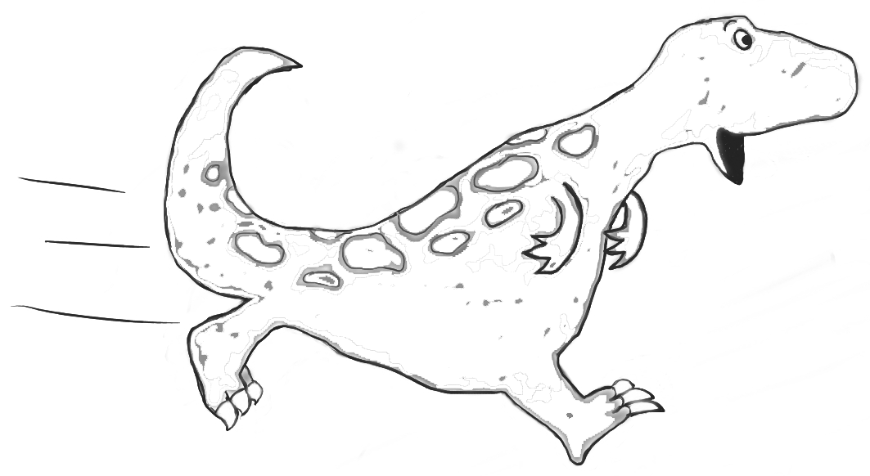 | What do I need to do?   | Who’s going to help me and when?   | How did I get on? 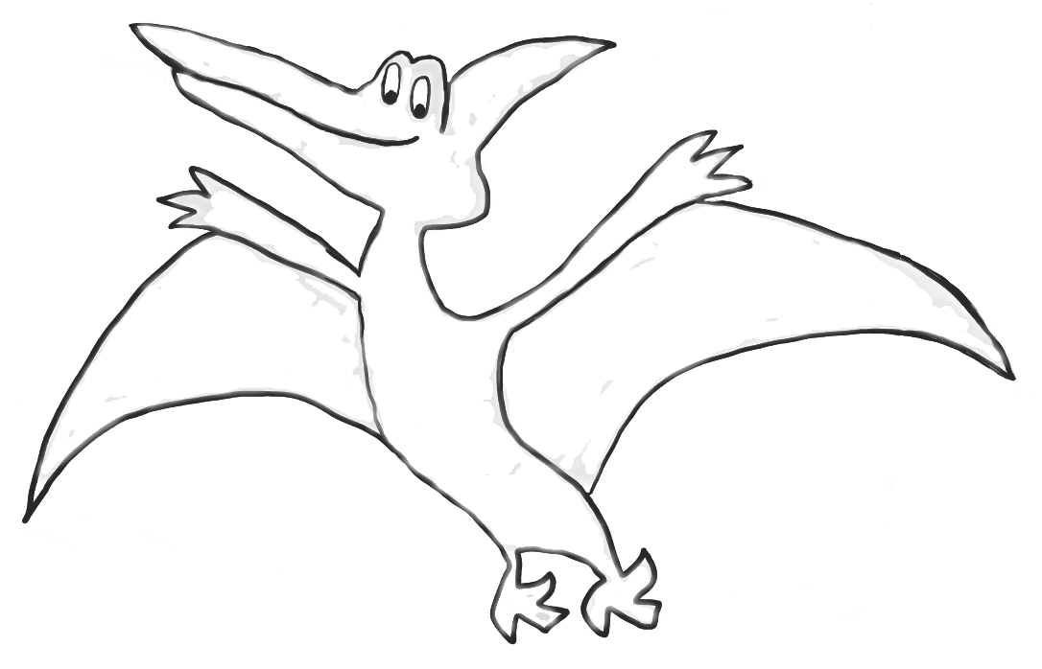  review date
To work alongside other pupils without getting into arguments about sharing  Remembering to put my hand up to talk | To work with Jay and Lewis for 30 minutes in the morning and 30 minutes in the afternoon being nice to, and sharing with, them.  To put my hand up every time I want to say something during the first half of a lesson. | If I feel myself getting angry I will not hit out. Instead I will ask Mrs Jones for a time-out and go into the Chilling Zone to do my “Super Cool” exercises.  Always sit facing the spotter to remind me by out putting my hand up. | Mrs Jones will go through my “Super Cool” exercises n with me, Jay and Lewis for 10 minutes in the morning and afternoon. If I play nice and share for the next 20 minutes Mrs Jones will put a MELLOW AS A CELLO sticker on my Super cool Chart. if I get 8 or more stickers in a week Mrs. Jones will give me a Super Cool Certificate to take home on Friday and Mam and Dad will give me a weekend treat.  Mrs Smith will give me a sticker if I manage to remember for the first half of a lesson and don’t call out. | (NB: A review date is set at the beginning of the process but the desired behaviours are shaped and reinforced throughout the process)

This IEP format has been designed especially for the child. The idea is that the child’s teacher will spend some time discussing and writing the content in partnership with the child. This will help the child to feel more involved in their education and therefore more motivated to reach the targets they have helped to set for themselves.
Name: |  | Name: | SENCO:
COP stage: | COP stage: | Learner: | Parent:
wre: |  | Other(s):

Individual Behaviour Plans

An IBP is an integral part of a school’s behaviour policy. As a general rule an IBP which does not reflect and express the school’s behaviour policy and is not contextualised within the SEN Code of Practice tends to be little more than a bureaucratic exercise. A school’s behaviour policy should provide clarity in differentiating between an IEP and IBP.

School Action

- Behavioural target(s) may form part of an IEP
- When behaviour becomes a major concern a school should draw up an IBP. It is essential that parents are involved at this stage and that targets are specific, measurable, achievable, realistic with appropriate time-frames
- The child should be involved in discussions to agree targets and the age of the child should be reflected in the number of targets set and the tone and format of the IBP
- The review meeting will decide if targets have been met and whether a further IBP is required or not

School Action Plus

- If a second IBP is appropriate and the review decides that the child is still not meeting his or her targets it may be necessary to refer to the ECPS/BSS.
- Both services will expect to see evidence at School Action of 2 IBPs, but will be flexible enough to recognise that sometimes 1 IEP with behavioural targets and 1 IBP will be sufficient to trigger external support

A graduated response to behaviour is essential to prevent schools becoming multiple, crisis-driven referrers and external agencies from being overwhelmed. Using IEPs/IBPs in the context of the School Action/School Action Plus processes as laid down in the SEN Code of Practice will ensure that graduated response which is designed to support the child with behavioural difficulties. It is recognised that there will be occasions when the need is so great or the incident so serious that normal protocols may be superseded.

Exemplar

What do I find difficult?
To work alongside other pupils without getting into arguments about sharing.

My target
To work with Jay and Lewis for 30 minutes in the morning and 30 minutes in the afternoon being nice to, and sharing with, them.

What do I need to do?
If I feel myself getting angry I will not hit out. Instead I will ask Mrs. Jones for a time-out and go into the Chilling Zone to do my ‘Super Cool’ exercises.

Who’s going to help me and when?
Mrs. Jones will go through my ‘Super Cool’ exercises every morning and work with me, Jay and Lewis for 10 minutes in the morning and 10 minutes in the afternoon. If I play nice and share for the next 20 minutes Mrs. Jones will put a MELLOW AS A CELLO sticker on my SUPER COOL CHART. If I get 8 or more stickers in a week Mrs. Jones will give me a SUPER COOL CERTIFICATE to take home on Friday and Mam and Dad will give me a weekend treat.

How did I get on?
A review date is set at the beginning of the process but the desired behaviours are shaped and reinforced throughout the process.

APPENDIX E
Positive Behaviour Support Planning Tool

(Revised June 2012)

Incident Report

This form should be completed by the supportive lead if the following has occurred:
◻ A pupil has exhibited a challenging behaviour with a risk attached to it.
This form should be completed by all witnessing the behaviour if one or more of the following has occurred:
◻ A pupil and or member of staff has been injured as a result of incident.
◻ A pupil has exhibited a challenging behaviour with significant and potentially harmful damage to the physical environment.
◻ A physical intervention has been used.
◻ An incident of challenging behaviour and or use of physical intervention has occurred in public.
◻ A pupil has made an allegation against a pupil/member of staff.
Name(s) pupil(s) involved
Location of Incident
Class Teacher
Report completed by (print name)
Staff Signature
Date
SMT/Behaviour Analyst Signature
Date

1. Describe the incident
Start time: |  | End time:
Where did the incident occur?

Who else was present? (Staff, service users, members of the public):

Behaviours towards self | Behaviours towards others |  | Behaviours towards the environment

Describe the incident in stages: (Exactly what happened during the incident?)
Antecedent (Trigger: What happened immediately before?):
1.
2.
Behaviour (What did the behaviour look like during the incident?):
3.
4.
5.
Consequence (What happened immediately after the incident):
6.
7.
8.

2. Physical Intervention (Complete only if a Physical Intervention used)

Was a Physical Intervention used? Yes/No

(If yes, continue to complete section 2. If no, go to section 3.)

- Tick Physical Intervention(s) used? (✓)

Physical Redirection / Reassurance |  | Describe any other intervention used.
Two Person Physical Redirection |  | Describe any other intervention used.
One Person Move |  | Describe any other intervention used.
Two Person Move |  | Describe any other intervention used.
Stabilisation (State Which) |  | Describe any other intervention used.
Release (State Which) |  | Describe any other intervention used.

- Duration of Physical Intervention:

How long was the Physical Intervention?
Is this intervention prescribed within the pupils Behaviour Management Support programme? Yes or No

Have all of the staff involved received formal training in how to carry out this intervention?
If no, list the names of those staff not trained…

- Names of all staff involved in the Intervention (Print names)

Name | Position in Intervention  (e.g. Head, right arm, legs etc)

Type of Support | ✓ | Notes
1. Medical Attention if needed?
2. A Break?
3. Change of Pupil allocation
4. Extra Support? (Specify)
5. Other (Specify)
- Were staff involved offered post incident Staff Support? Tick what kind (✓)

3. Injuries

(Complete only if pupil or Staff injured)

(Further details of injuries should be recorded in the accident book.)

Were there any injuries? (Delete as appropriate) Yes/ No (If no, go to section 4.)

If yes, has the accident book been completed? Yes/No

Accident Book Reference No: _________________

- Pupil Injuries (Describe) b. Staff Injuries (Describe)

4.

Staff Signatures - Please read the information contained in this report carefully as by signing it, you are agreeing to what has been recorded. All staff involved in any reactive intervention must sign this section.

Name: | Signature: | Date:

Head Teacher/Senior Staff/Behaviour Analyst Comments:

SMT/Behaviour Analyst Name: _________________________ Signature:_____________________

- Incident forms must be signed by SMT/ Behaviour Analyst.
- Incident forms must be logged with members of the administration team and will be further analysed by the onsite Behaviour Analyst.

- Is a Critical Incident Review required? Yes / No
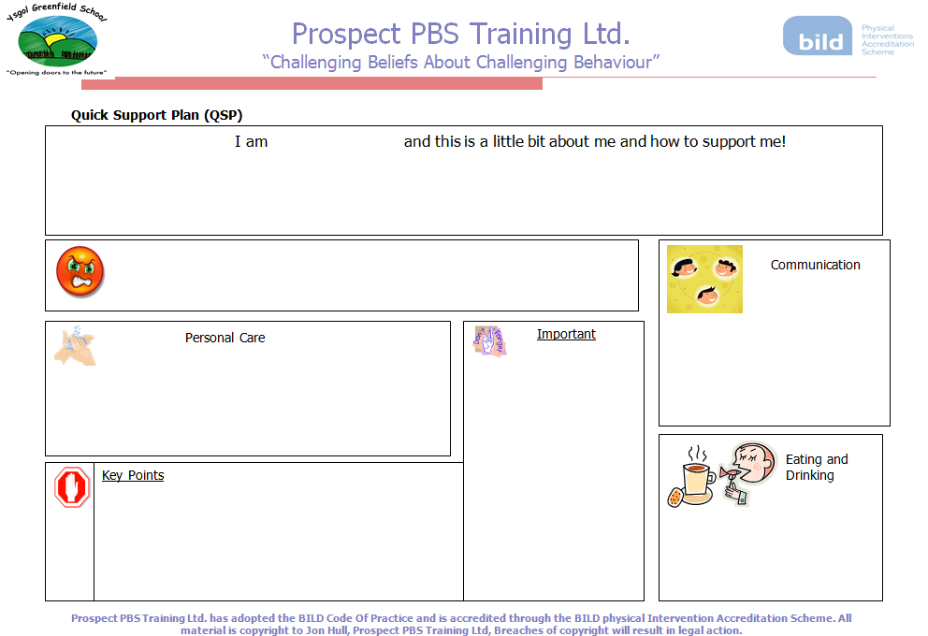

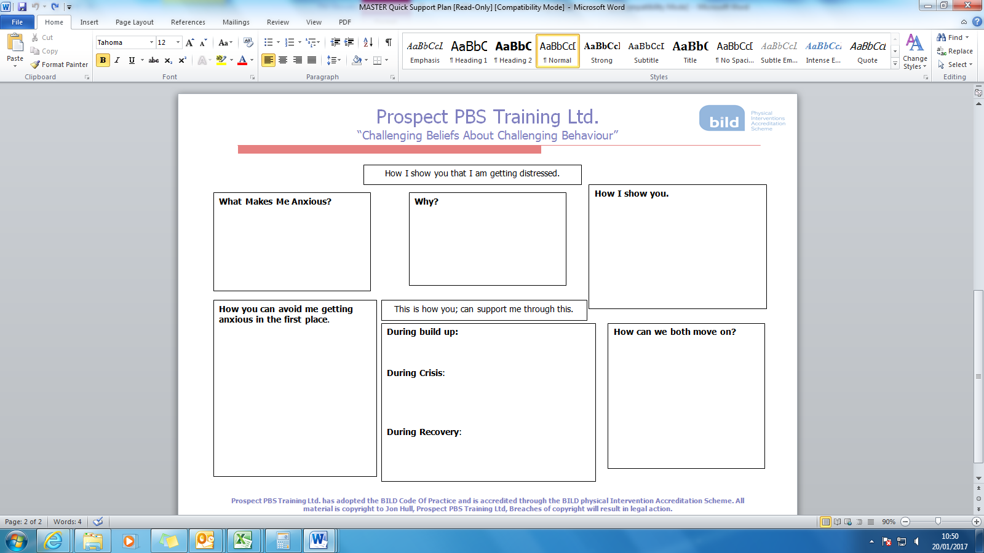

Prospect PBS Training Ltd.
“Challenging Beliefs About Challenging Behaviour”

Basic Scatter Plot
Name:

Date – Week ending:

Day/Date | Mon | Tue | Wed | Thu | Fri
Time
8.50
9.00
9.30
10.00
10.30
11.00
11.30
11.45
12.45
1.00
1.30
2.00
2.30
3.00
3.30

Number | Behaviour | Code
1 |  | 1
2 |  | 2
3 |  | 3
4 |  | 4
5 |  | 5
6 |  | 6
Number | Area/classroom | Code
A |  | A
B |  | B
C |  | C
D |  | D
E |  | E
F |  | F
G |  | G
H |  | h

Prospect PBS Training Ltd. has adopted the BILD Code Of Practice and is accredited through the BILD physical Intervention Accreditation Scheme. All material is copyright to Jon Hull, Prospect PBS Training Ltd, Breaches of copyright will result in legal action.

Neither Jon Hull or Prospect PBS Training Ltd. accept any responsibility for the Physical Interventions Chosen by you for your particular use
STAR Analysis Tool Name:
Behaviour exhibited:
Date | Staff  involved | Setting Conditions  E.g. Change to medication; Illness; Sleep disruptions; Changes to staff or home/class routine; Known levels of environmental sensitivity (i.e. noise, light); Diagnosis (i.e. Epilepsy, ADHD, ASD) | Trigger  Occurs immediately before the behaviour takes place: e.g. transition from activity/between areas; demand given/request made; interactions with peers/staff; preferred activity/object finished; waiting. | Action  The actions of the child during the incident: be more descriptive-e.g. what did they hit/kick/shout? | Results  Anything that happens immediately after the incident, including both staff and pupil: e.g. redirected to another activity; directed attention to preferred behaviour; allowed to leave situation; interaction from peers/staff; clear instructions given.

A STAR Analysis is a helpful way of assessing what happens before, during and after an episode of unacceptable behaviour
Appendix E – Risk Assessment Form
BEHAVIOURAL RISK ASSESSMENT MATRIX |  | Assessment No.
Name of individual.
Behaviour exhibited.
Who is the risk to (self/other/environment).
Behaviour Support Plan No.
A) How likely is behaviour to occur?
 | Description | Tick
Rare | This event may occur again but only in exceptional circumstances e.g. less than once per year.
Unlikely | There is a slight chance of this event occurring again e.g. one to twelve times per year.
Possible | It is quite possible that this event will occur again e.g. one or more sessions per month up to weekly.
Likely | This event will occur again at some time e.g. one or more sessions per week up to daily.
Almost certain | This event will occur again on a regular basis e.g. one or more sessions per day.
B) What are the likely consequences 1). If the risk actuates (potential)? 2). Based on data (current).
 | Description | Tick (1.) | Tick (2.)
Negligible | No injury/ damage to persons or property, may impact on quality of life.
Minor | Minor injury/ damage to persons or property, consequences can be managed internally. May significantly impact on quality of life.
Moderate | Serious (or potential) injury or damage to persons or property, consequences may not be managed internally.
High | Serious (or potential) injury or damage to persons or property, incident needs reporting to authorities and assessment of placement is needed.
Very High | Death or immediate cessation of placement.
RISK ANALYSIS MATRIX
Please underline potential risk (1.) and circle current risk (2.)
 | Consequence
Likelihood | Negligible | Minor | Moderate | High | Very High
Rare | 1 | 2 | 3 | 4 | 5
Unlikely | 2 | 4 | 6 | 8 | 10
Possible | 3 | 6 | 9 | 12 | 15
Likely | 4 | 8 | 12 | 16 | 20
Almost certain | 5 | 10 | 15 | 20 | 25
Key (enter score)
1. | 2. |  | Risk score | Action
 |  |  | 12-25 | High risks. Emergency guidelines must be written to reduce risk to acceptable level.  Senior Management Team to assess viability of placement.
 |  |  | 5-10 | Medium risks. Review and amend existing control measures to determine effectiveness.
 |  |  | 1-4 | Low risks. Ensure behaviour support plan is in place.

