MERTHYR TYDFIL COUNTY BOROUGH COUNCIL
Civic Centre, Castle Street, Merthyr Tydfil, CF47 8AN

Main Tel: 01685 725000 www.merthyr.gov.uk

FULL COUNCIL REPORT
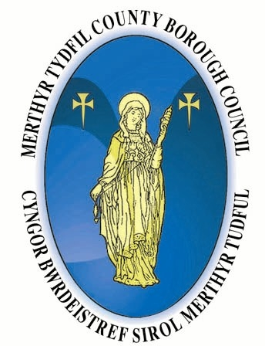
Date Written | 28th October 2011
Report Author | Lisa Emerson
Service Area | Corporate Property & Physical Regeneration
Exempt/Non Exempt | Exempt
Committee Date | 9th November 2011

To: Mayor, Ladies and Gentlemen

21ST Century School Programme, New Building for Ysgol-Y-Graig Primary, Cefn Coed

PURPOSE OF THE REPORT:

To agree a location of the preferred site for the proposed replacement of Ysgol Y Graig Primary, Cefn Coed.

INTRODUCTION AND BACKGROUND

1.1 Council will be aware that the Strategic Outline Programme (SOP) for the 21st Century Schools Programme was approved by Council on 8th December 2010 and subsequently submitted to the Welsh Government. A decision in terms of the funding and phasing of the programme is still awaited. Should the proposal be successful the initial design work to RIBA Stage C has been undertaken.

1.2 As part of the concept stage and building on an earlier scoping exercise, a range of sites in the Cefn Coed area has been considered as candidate sites for the new school. In essence, two sites have been identified:-

- Site of former Vaynor and Penderyn High School.

- Godre’r Coed Playing Field (Former Vaynor and Penderyn High School playing fields),

INFORMATION

2.1 Cefn Coed whilst being on the fringe between urban/agricultural environment is itself typified by a very tight built character with narrow historic road infrastructure. As a result there is little open land in its centre and access such as to the existing Ysgol Y Graig Primary site is difficult and a long way below, modern planning and highway standards. This tight pattern of existing development also make the up grading of potential access points impossible without significant acquisition of adjoining properties which apart from financial viability would create major social issues.

  - The former Vaynor and Penderyn High School site is irregular in terms of shape and levels, for which the type of development proposed would give rise to issues such as retaining walls. Due to the restricted size of this site, it is clear from the development report that this site would not provide sufficient space to include sports provision. Therefore for this to be a viable option in terms of the proposed future development it is proposed that it would be developed in conjunction with the Godre’r Coed site being the school playing fields as was the case when the high school was operating. However, whilst not being ideal it is a significant improvement over the position of the existing Ysgol Y Graig Primary.

  - The Goedre’r Coed site was previously the dedicated playing fields of the former High School and has continued to be used by clubs and the community for sporting and recreation purposes.

  - Given the work done within the Stage C report, whilst there are differences between the two potential sites, the general conclusion is that there are no major issues that would rule out deliverability of either site.

  - Consultation has been held with the community over the emerging proposals with the focus on the two most viable sites referred to above. The aim of the public consultation was to capture and understand the views of all interested parties to aid the decision making process as to which site the new school should be built on.

  - Details of the advantages and disadvantages of both sites were displayed at the public consultation and the event on the 23rd March 2011 was well attended. . Attendees were requested to fill in questionnaires and 254 completed responses were received.

The questionnaires included 4 questions, the first two of which asked for contact details and whether they were parent/guardians, staff, community or other. Question 3 asked for comments in respect of Site 1 (Vaynor and Penderyn School) and Question 3 asked for comments in respect of Site 2 (Godre.r Coed Site).

  - The overwhelming opinion was that the school would be sited on the former Vaynor and Penderyn High School site (with a few people picking up the significance of the need to utilise in conjunction with Godre’r Coed site), 138 responses directly for site 1 and 99 against site 2. The most significant response against site 2 was 184 “Fields are used by the children and the local sports team and have been for years – don’t want to lose this”.

  - Summary

It is clear that the scheme can be delivered on both sites.

The aim of the consultation process was to capture and understand the views of all interested parties to aid the decision making process. It is evident from this exercise that the local community are overwhelmingly against the development of the Godre’r Coed.

RECOMMENDATION that

3.1 Members identify the former Vaynor and Penderyn High School site as the preferred site for the re-location of Ysgol Y Graig Primary to be utilised in conjunction with the existing playing fields at Godre’r Coed, should funding become available to proceed.

GARY THOMAS
DIRECTOR OF CUSTOMER SERVICES

BACKGROUND PAPERS
Title of Document(s) | Document(s) Date | Document Location
Report to Council: 21st Century School programme | 8th December 2010

Consultation has been undertaken with Executive Board in respect of each proposal(s) and recommendation(s) set out in this report.

